ASSIGNMENT-2

NAME: M. Jahnavi

EMAIL: [jahnavimuppalla9@gmail.com](mailto:jahnavimuppalla9@gmail.com)

Phone number: 8074116848

Roll Number: 20NN1A1286

College: Vignan’s Nirula Institute Of Technology And Science For Women

1. App.js

1. App.css

1. Card.js

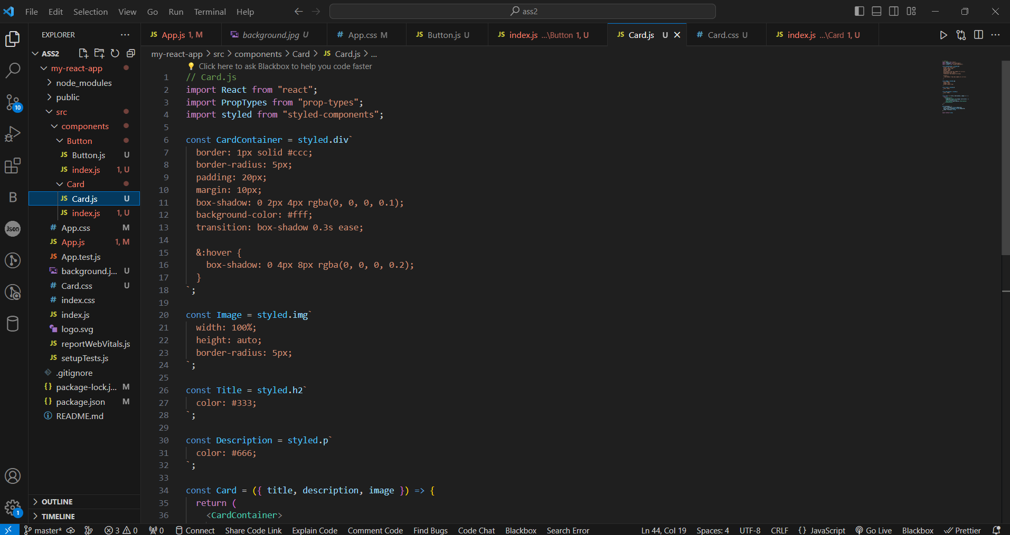

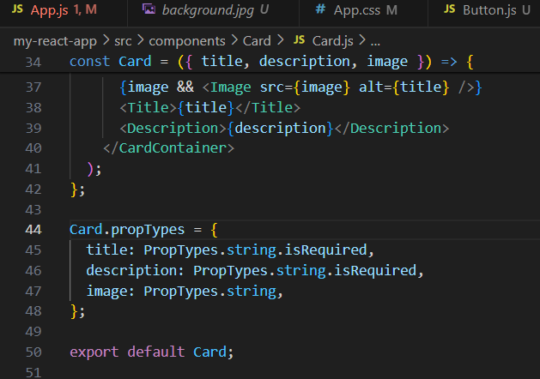

1. index.js

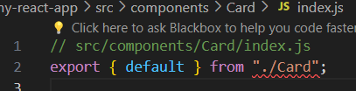

5.Button.js

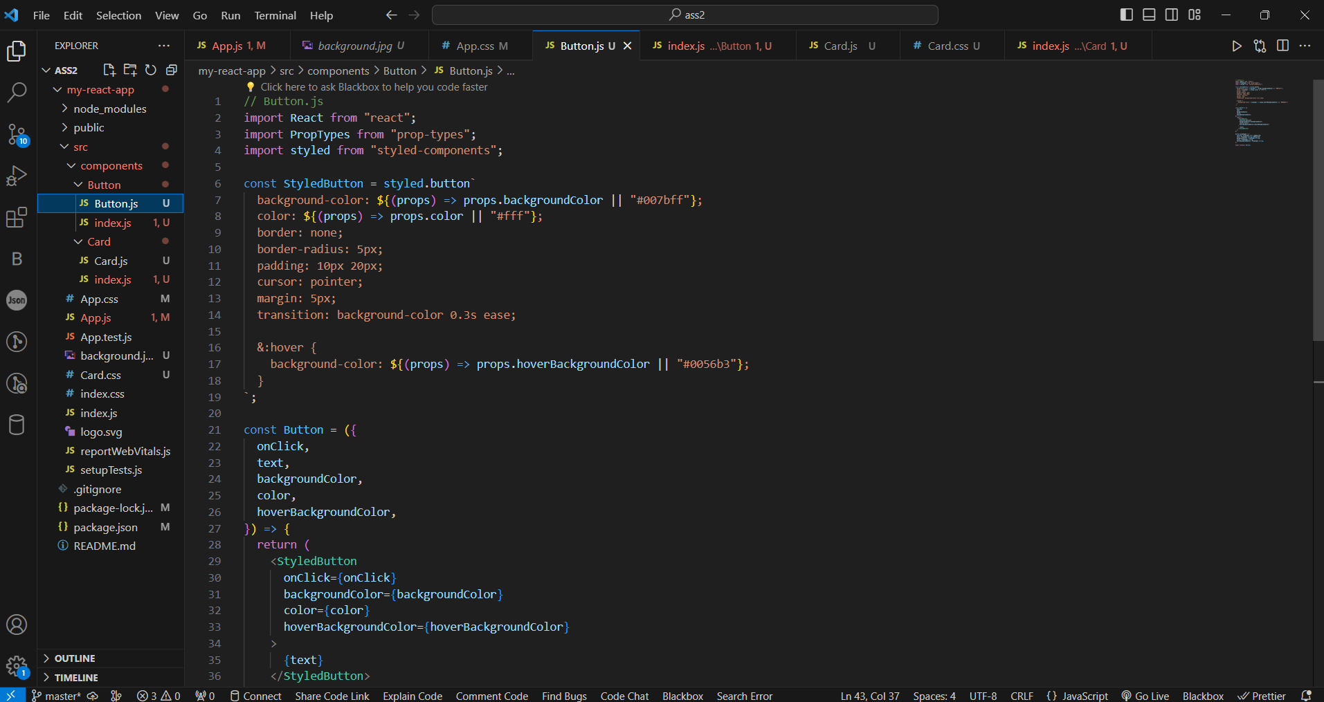

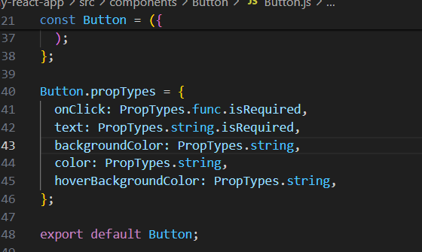

6.index.js

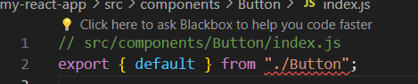

7.Card.css

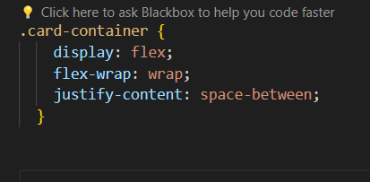

8.Output:



